McRoberts DynaPort Manual
1. Preparing the device for measurement
- Check if fully charged (+- 3hours: blinking green = charging / green = full)
- Battery life: +- 5-7 days
Note: If not in use – fully charge every 3 months (<battery performance)
Note: Make sure Dynaport Manager is on (Programs 86x – Mcroberts – Run)
- Connect a Dynaport to your pc (Blue and Green light)
  - Devices tab : Information tile (https://my2.mcroberts.nl/)
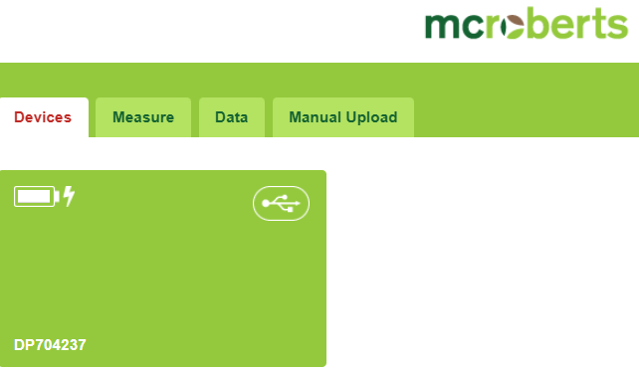
  - Choose a device : click on ‘tile’
  - Go to the ‘measure’ tab
  - Select your device
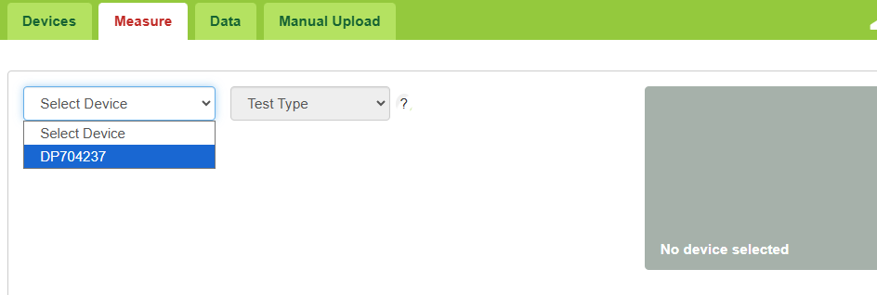

  - Select ‘Test Type’: MoviMonitor
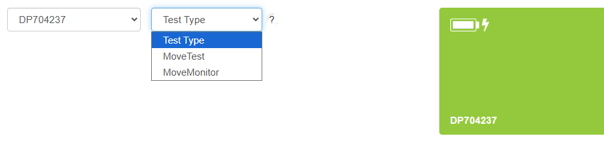
  - Select starting time: ‘Start’ – ‘Later’ – ‘Select Date’ – ‘Select Starting Hour’ (Clock) (always start day after at 7 am)
  - Select duration: 7 days
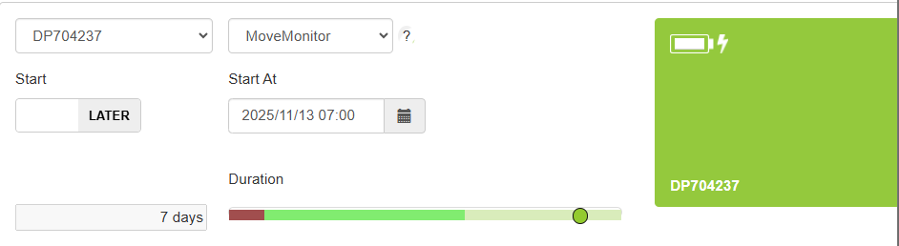
  - Project and subject characteristics: Select
    - Usual Care
    - Optimal Care
  - Add new Subject:
    - Subject code: ‘M’’NumberParticipant’
    - Year of Birth: ‘1900’ (Click 1 down)
    - Weight: ‘See Participant’
    - Height: ‘See Participant’
    - Gender: ‘See Participant’
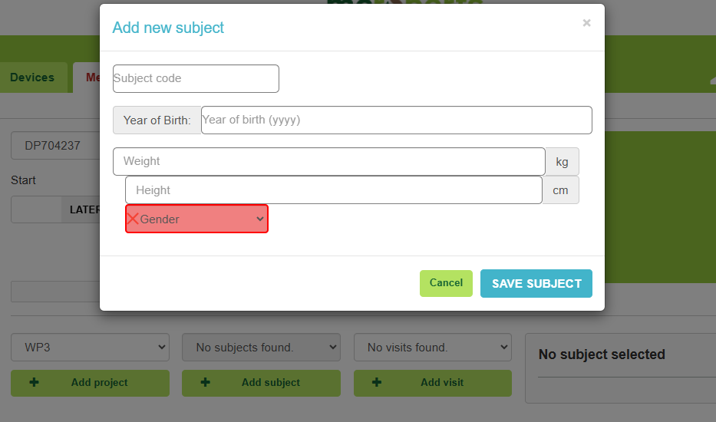
  - Add or select new visit: ‘1’ (Only 1 visit after 7 days)
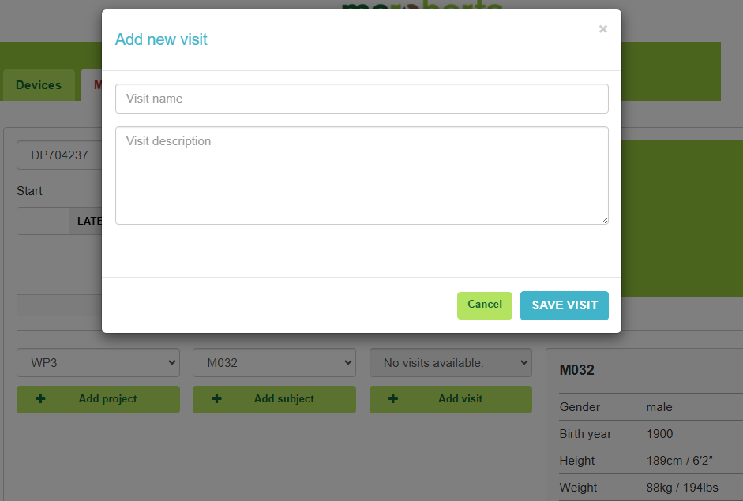
  - Click on ‘Start Measurement’
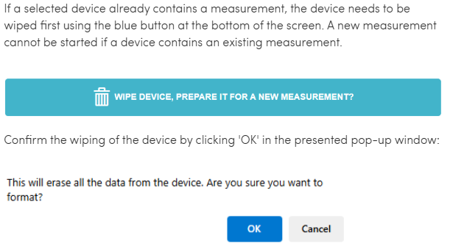

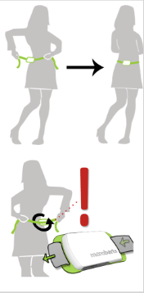
- Wearing the device
  - Around the waist (on skin or over thin layer of clothes)
  - NOT WATERPROOF (no showers!)

2. Processing the data
- Automatic uploading (Manually also possible – open file and drag to portal)
  - Attach DynaPort to PC
  - Data will automatically be uploaded (If not working, open ‘Manager’)
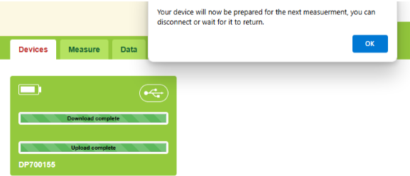

- Measurement statuses: all information about currently performing and performed measurements
  - Go to Data

  - Click ‘Overview’
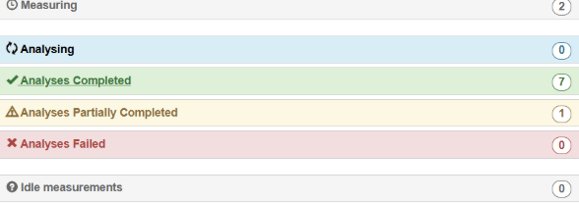
- Measuring: measurements currently being performed
- Analysing: measurements that have just been uploaded
- Analyses Completed: analysed and reports are ready (SHORT)
- Analyses Partially Completed: only in ‘MoveTest’
- Analysies Failed: Support Team will be automatically notified
- Idle measuremetns: fits not in 1-5

- Project Data
  - Measurements can be viewed per project: Look below ‘overview’
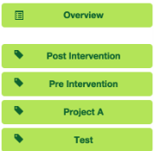
  - Go to ‘Subjects’: select ‘Subject’
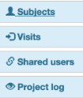
- Shared users
  - Project can be shared with colleagues
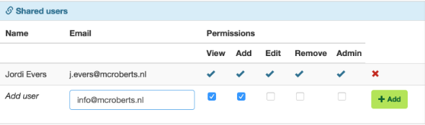

- Full analysis in csv file (1 week duration):
  - Check: https://support.mcroberts.nl/portal/en/kb/articles/requesting-a-data-transfer-of-your-data
  - Fill in the form and send through e-mail

Note 1: Firmware upgrade – how to – see one drive (note block file)

